Executive Summary: TBSC

(The Busines Software centre)
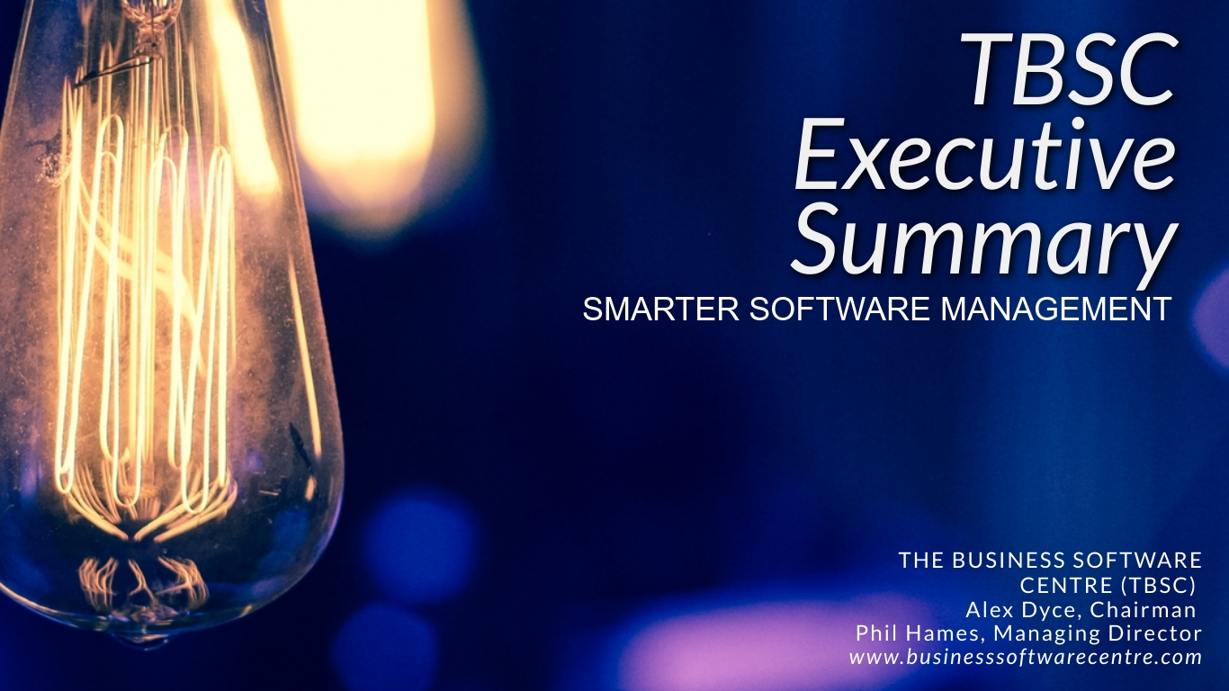

Author: Phil Hames
Issue Date: 17.11.20

Business Description
TBSC is an international company with Offices in Basingstoke UK and a sales location in California USA. Our goal is to optimize the use of software licenses for end user clients and work with channel partners to develop their sales of software and services. The move to cloud computing and software as a service (SaaS) is a major opportunity for TBSC.

The Software as a Service (SaaS) market in 2020 is forecast to be worth $330bn (Gartner). However, TBSC research reveals that 75% of subscriptions are not managed and the other 25% have complex and time- consuming management methods. The overview of our business strategy is as follows:
- TBSC automates the analysis and management of SaaS for end user and gives visibility and clarity for their channel suppliers.
- Our initial addressable market is the Microsoft365 subscribers which is 200miliion worldwide of which 5% are in UK. They pay on average $15 per month ($36,000m per yr globally). We target the 250 to 5,000 users as they have no inhouse specialists on license management and they have been encouraged to move from traditional licensing to monthly payments by MS. Our estimate is 5million in UK and 80million worldwide with a current growth rate in excess of 35%.
- Our competition focusses on cost cutting by eradicating subscriptions and is primarily direct sales focussed on larger accounts. TBSC optimizes usage and improves ROI for end users as well as optimizing costs. In addition, TBSC has a channel distribution model which gives TBSC wider reach and market engagement including reference selling from Microsoft on their ISV co-sell program.
- The future holds great expansion possibilities with:
  - Step 1 Microsoft 365 and addon services and value propositions
  - Step 2 – 40 additional SaaS vendors ready to be added into the service, covering major brands e.g. Salesforce, Adobe, Google Yr1/Yr2
  - Step 3 - Information services, IOT and other SaaS subscriptions with our universal API which provides ease of connectivity to our portals to cover a multitude of cloud base subscription services. Yr2 onwards
- Key point:
  - Sales of over 80,000 subscriptions for Smarter SaaS 365 product since launch in May 20
  - Distribution channels in place
  - Further product developments underway
  - Approval of TBSC as a Microsoft ISV for the co-sell program, this includes financial support.
  - We are an approved EIS company

Our Products
TBSC has developed Smarter SaaS 365 and Smarter SaaS Universal. For end user organizations these products optimize the usage of their SaaS subscriptions to maximise the ROI on their IT investments. These technologies also link into our Smarter Distribution Portal which analyses end user behaviour and reveals sales and marketing opportunities for channel partners.
In addition, we have a range of products which provide software inventories and reporting for on premise software.
Our product range includes the following:
Smarter 365 – launch 1st May
Smarter SPLA – launch 1st May – 5k installs
Smarter App usage – available now
The problem we are solving:
SaaS is the big growth area for software delivery with over 21% CAGR per annum however over 75% of subscriptions are unmanaged. This means organizations fail to get the efficiency improvements they expect from the new products. IT channels need to adapt their business model from just being sellers of software licenses to become managed service providers. TBSC equips channel partners with tools that enable them to provide the managed services for their customers – quickly, effectively and cost efficient. Optimized usage of SaaS is our key goal. We align our goals with what the source vendor e.g. Microsoft and their channels want, in this way we get support from these organizations to grow our distribution capacity.
TBSC is an approved co-sell partner for Microsoft which means they will sell our technology and recommend it. Smarter 365 can be use by Microsoft channel partners for usage optimization and then have it paid for by Microsoft from marketing co-op funds.
TBSC has the potential to be a major player in the new SaaS market by providing a technology which optimizes end user SaaS usage and increases channel revenue potential. The developers of SaaS software also benefit from increased consumption and sales of additional products and services. Key USPs are:
- A “single pane of glass” for all SaaS subscription management
- A channel portal which helps grow sales and usage levels for SaaS resellers
- Microsoft funding for resellers to use Smarter 365 and fund it from marketing co-op funds
Routes to Market and Commercial Progress
TBSC has contracts which deliver over £150,000 of annualized revenue. Turnover in the last financial year was over £180,000. Currently the sales pipeline is for over £400k in current year.
TBSC provides products and services to optimize licensing from many software providers however our close working relationship with Microsoft means that we have an emphasis on working with them and their sales channels. This relationship gives us the following advantages:
- We are an approved Independent Software Vendor (ISV) on the Microsoft “co-sell” program. This means that Microsoft will sell our products through their cloud marketplace, the Microsoft sales staff and Microsoft distribution channels. TBSC has a dedicated Microsoft Partner Development Manager who assist TBSC in developing sales opportunities.
- TBSC has approval from Microsoft for their sales channels to use Microsoft marketing funds to pay for Smarter 365 to be used to build usage of key Microsoft apps. This means the partners can pay TBSC but claim the cost back from Microsoft.
- Microsoft has worldwide distribution channels which consist of resellers and distributors. By working with distributors and selected resellers TBSC can create a network of sales outlets that build our distribution capacity and streamline our order processing and administration
TBSC has signed contracts with the following distributors:
Tech Data – largest in Europe
Westcoast Cloud – Largest in UK
Grey Matter – specialist distributor in technical ISVs and VARs
Additional selling cycles for major deals in progress with other channels.
The above organizations are distributors who supply resellers who supply end users – Typical engagements can be SMEs but also major accounts e.g. Marks and Spencer, Deutsche Bank, Astra Zeneca, Sharp Europe, WH Smith.
The SaaS marketplace
SaaS is the growth area in software licensing. Users subscribe for services which include hosting, updates and the actual software. Over 75% of subscriptions are unmanaged which means many subscriptions are underutilised or never used at all. The traditional IT channels are losing market share in this business model with only 23% of SaaS subscriptions going through channels.
The overall SaaS market is growing at 21%CAGR. The main markets are N. America 48%, Europe 35%.
Our existing three distributors have over 1million Microsoft 365 subscribers in the UK. Tech Data has 2 million across Europe.
Competition comes from 3 main sources:
- Manual analysis – done by downloading data and consultant analysis in spreadsheets
- SAM tool vendors – typically aimed at cost cutting of SaaS subscriptions. Two major majors are Snow and Flexera which were both reviewed by one of our major prospects against our technology. Their view was neither companies have products that work to any great extent and that TBSC technology was way beyond anything else they had seen.

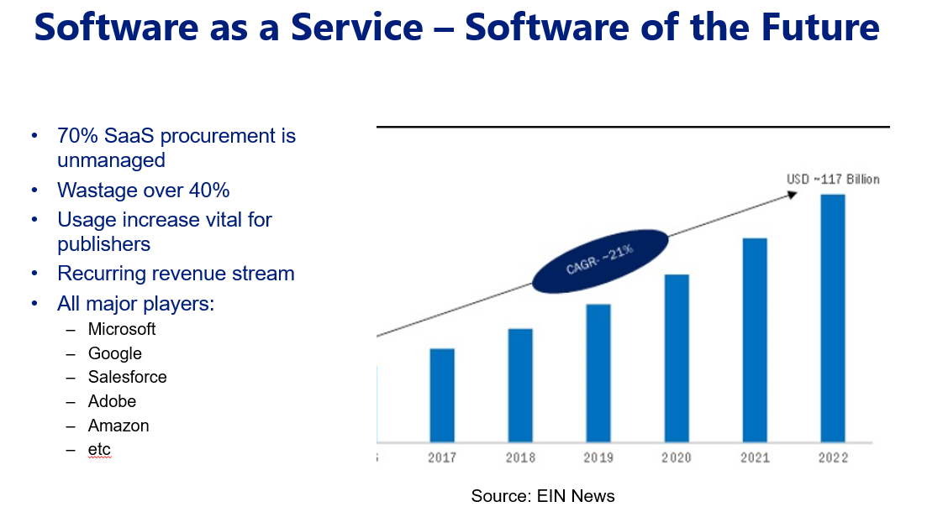
TEAM
Alex Dyce – Chairman: Ex-director of Barclays Bank. Experienced NED and investor in companies creating disruptive technologies.
Phil Hames – Founder & MD – Ex-sales director in software companies and business manager at Xerox. Background in IT and software. Actively involved in sales, product and business strategy.
Mohit Singhal – CTO – Experience in development strategies and e-commerce. (P-T)
Joyti Khule – Development Manager – Over 10 years in software development working in and running agile development teams.
Qui Mai – Operations Manager – MBA graduate, over 5 years in TBSC. Ex – country manager for Budweiser.
Madison Miller – Marketing – Masters degree. Responsible for marketing campaigns.
Edardy Sukayman – Marketing Strategy – Creative design background and strategic marketing in software organizations. (P-T)
Rob Luppi – Commercial Advisor – Specialist in software licensing. Over 11 years in software licensing with a focus on cloud and managed service providers. (P-T)
Jessica Pitts- Brennan – Business Development/Sales Manager – Background in cloud and software licensing sales in Google, Rackspace and Bytes.
Dan Clark – USA Sales – Over 30 years in running own business. Background in developing usage-based software for office equipment. (P-T)
Financial Projections
See chart below
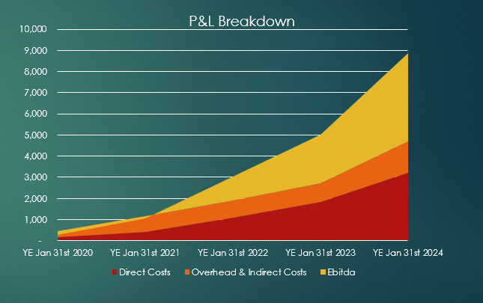

Future Strategy
TBSC is looking for an exit in 3 to 4 years depending on revenue growth.
TBSC monitors customer acquisition costs (CAC) and Lifetime Customer Value (LTV) as the basis for a revenue growth model. There is a high focus in keeping customer churn rates low.
A successful exit will provide a revenue to sell price ration of 4x revenue.
TBSC has 4 key milestones:
- Revenue of £400k/yr to prove business model. Further investment for sales growth
- Revenue of £1m. Develop channel model and add value in product range
- Revenue of £2m+. Continue to expand and organize due diligence preparation
- Revenue £4m+. Consolidate revenue model and value add. Prepare for company sale.

