CANDIDATE BRIEF
Brief for the position of
Non-Executive Director, Mattioli Woods plc
May 2020

Mattioli Woods plc

Introduction

A 21st century financial services business, built with expertise, integrity and delivered with passion.
Mattioli Woods is a leading UK provider of wealth management and employee benefits, with offices in Aberdeen, Belfast, Birmingham, Buckingham, Edinburgh, Glasgow, Leicester, London, Manchester, Newmarket, and Preston, growing both organically and by acquisition to deliver strong, sustainable shareholder returns over the long term. We administer over 10,000 clients and hold £9.4 billion of assets. We pride ourselves in building long-term relationships to provide trusted advice, high standards, and a personalised delivery.
We are a leader in the provision of self-invested personal pension and small self-administered pension scheme arrangements, both of which are central to our clients’ life-planning strategies. This expertise has continued to grow into full wealth management, cemented by the addition of our employee benefits division.
We grow both organically and by acquisition and are delighted to have welcomed excellent like-minded companies into the group – businesses that share our value of providing the highest levels of personal service.
Today, as back then, the overriding passion is to deliver the best possible outcomes for the people who trust us to look after their wealth. It is a responsibility we feel privileged to shoulder, whether that be through pensions, investments, healthcare or innovations like our Structured Products Fund.

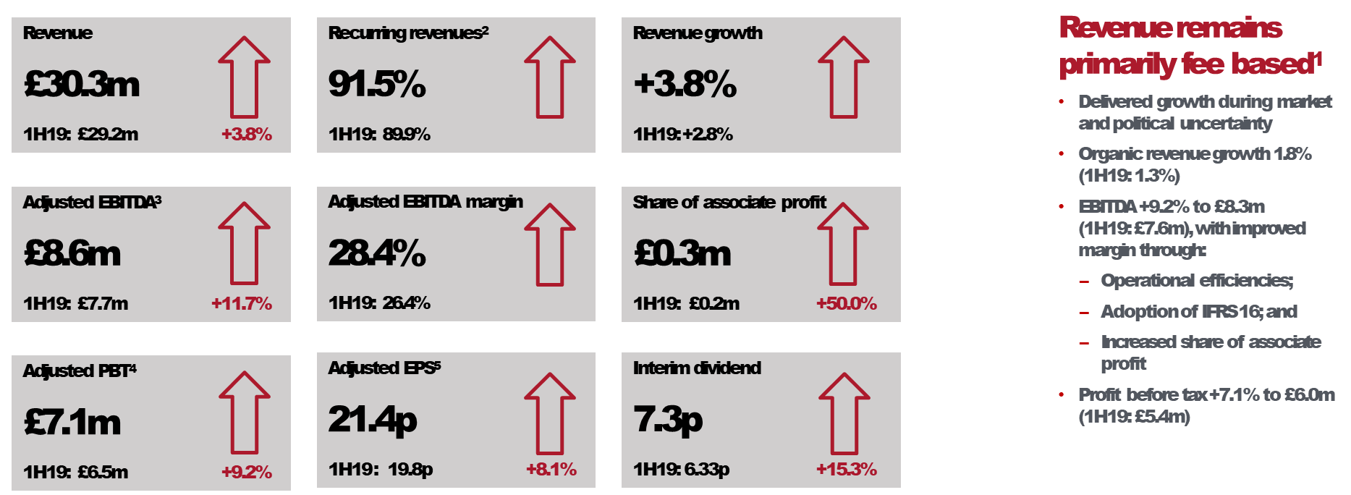
Interim Results Highlights 2019

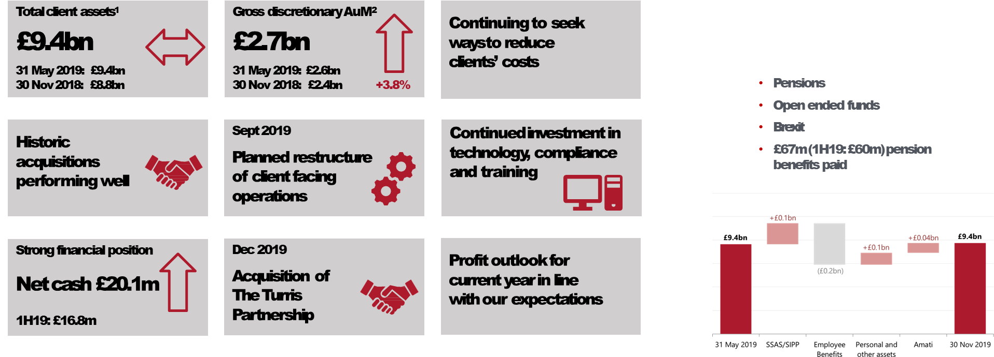

Strategy
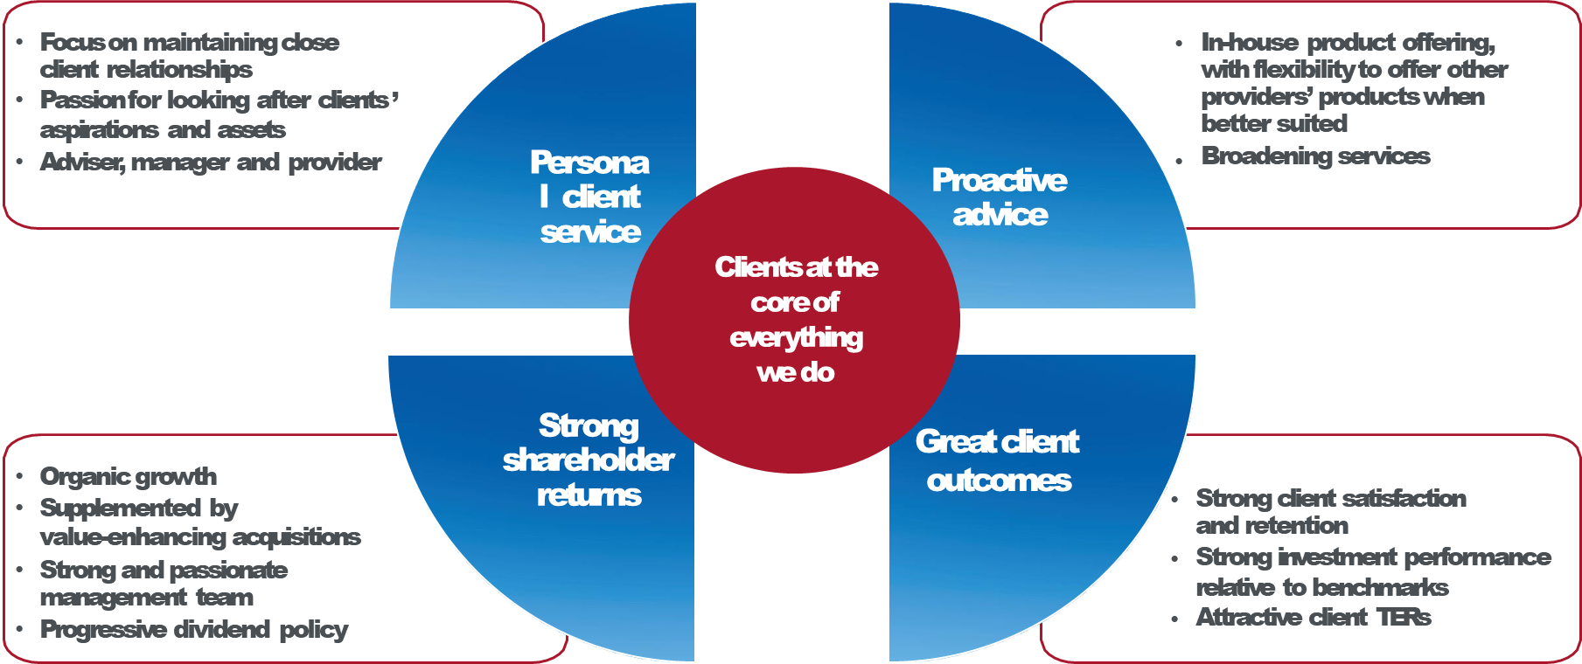

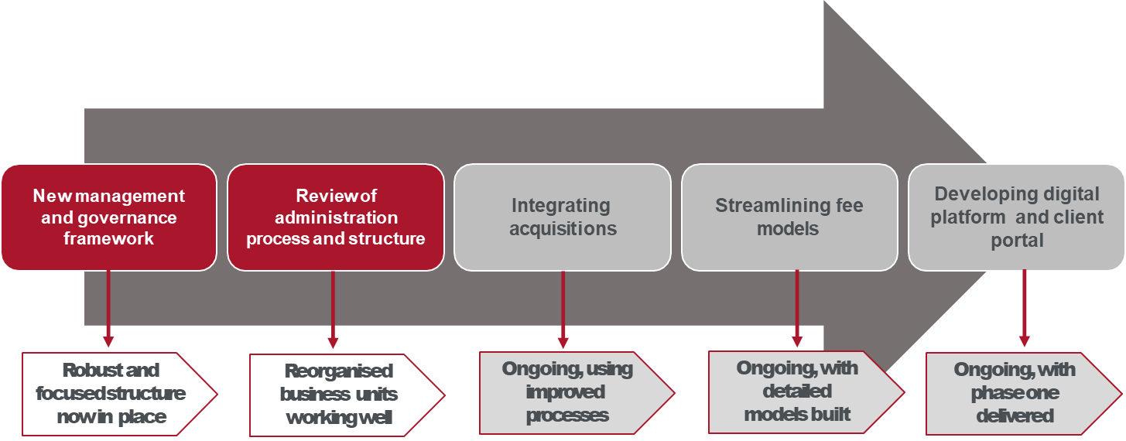
Operational Priorities

Mattioli Woods Board of Directors

Independent Non-Executive Chairman

Joanne Lake
Joanne was appointed to the Board in July 2012. In June 2015, she became Deputy Chairman ahead of her appointment as Non-Executive Chairman at the Group’s Annual General Meeting in October 2016. Joanne has over 30 years’ experience in accountancy and investment banking, including with Panmure Gordon, Evolution Securities, Williams de Broë and Price Waterhouse. She is a Chartered Accountant and a Fellow of both the Chartered Institute for Securities & Investment (“CISI”) and the Institute of Chartered Accountants in England and Wales (“ICAEW”), and is a member of the ICAEW’s Corporate Finance Faculty. Joanne is also deputy chairman of Main Market-listed Henry Boot plc, a land promotion and property development company and a non-executive director of Gateley (Holdings) Plc, the first UK commercial law firm to list on AIM, and Morses Club plc, a UK non-standard consumer finance company.

Chief Executive

Ian Mattioli, MBE
Ian has over 35 years’ experience in financial services, wealth management and property businesses and, together with Bob Woods, founded Mattioli Woods in 1991. Ian is responsible for the vision and operational management of the Group and instigated the development of its investment proposition, including the syndicated property initiative that developed the seed portfolio for the launch of Custodian REIT plc, of which he is founder, non-executive director and Chairman of its discretionary investment manager, Custodian Capital. His personal achievements include winning the London Stock Exchange AIM Entrepreneur of the Year award and CEO of the Year in the 2018 City of London Wealth Management Awards.
Ian was awarded an MBE in the Queen’s 2017 New Year’s Honours list for his services to business and the community in Leicestershire. Ian is also Non-Executive Chairman of K3 Capital Group plc, which is listed on AIM and specialises in business transfer, business brokerage and corporate finance across the UK.

Chief Financial Officer

Nathan Imlach
Nathan is responsible for all financial aspects of Mattioli Woods’ operations and leads the Group’s acquisition activity. He qualified as a Chartered Accountant in 1993 with Ernst & Young, specialising in providing mergers and acquisitions advice to a broad range of quoted and unquoted clients in the UK and abroad. He is a Fellow of the CISI and holds the Corporate Finance qualification from the ICAEW. Nathan is Chief Financial Officer and member of the investment committee of the Group’s subsidiary Custodian Capital and Company Secretary to Custodian REIT plc, having led its admission to the Main Market of London Stock Exchange in 2014 together with Ian Mattioli and Richard Shepherd- Cross. Nathan is also Non-Executive and Senior Independent Director of AIM-quoted Mortgage Advice Bureau (Holdings) plc, a leading mortgage network, and a trustee of Leicester Grammar School.

Non-Executive Director

Carol Duncumb
Carol has over 35 years’ experience working in consumer-related companies and over the last 10 years has focused on online transactional companies to gain greater experience of changing consumer behaviours. Previously, Carol was the Chief Executive of Intimas plc and Managing Director of Wolsey Limited and has a strong understanding of managing businesses. More recently, her activities have included business angel investing into online consumer businesses. She manages a portfolio of investments, whilst advising successful entrepreneurs and management teams on developing their businesses.
As part of her Non-Executive role, Carol currently chairs Mattioli Woods’ Remuneration Committee.

Non-Executive Director

Anne Gunther
Anne was appointed to the Board in June 2016 and is Chairman of both the Audit and the Risk and Compliance Committees. Anne has spent nearly 40 years in retail financial services in the UK, with executive experience cross all sectors, from lending to wealth management, and including IPO, merger and acquisition activity. Anne has a significant background in direct channel delivery; her team having launched Lloyds Internet Banking, and then as Chief Executive of both Standard Life Bank and Standard Life Healthcare. She was a founding director of Standard Life Wealth.
Anne is a Chartered Banker and holds an MBA from Warwick Business School and a degree in Physics from Nottingham University. In her non-executive career, Anne has held roles in both the charitable and commercial sectors, and has also chaired Warwick Business School. In addition to her Mattioli Woods role, Anne sits on the Masthaven Bank board and chairs the Audit and Risk Committee, is a Non-Executive and Senior Independent Director and Chair of the Audit Committee for GBGI Limited, an AIM listed specialist health insurer, as well as being a director of the Water Plus Limited group, a jointly owned subsidiary of United Utilities plc and Severn Trent plc.

For further information:

Mattioli Woods website: https://www.mattioliwoods.com/

Annual Report & Interim Reports 2019: https://www.mattioliwoods.com/about/annual-interim-Reports

For further information:

First Flight Non-Executive Directors Ltd
19 Sayers Lane
Tenterden, Kent, TN30 6BW

Tel: 01797 270 271

Email: info@firstflightnonexec.com

